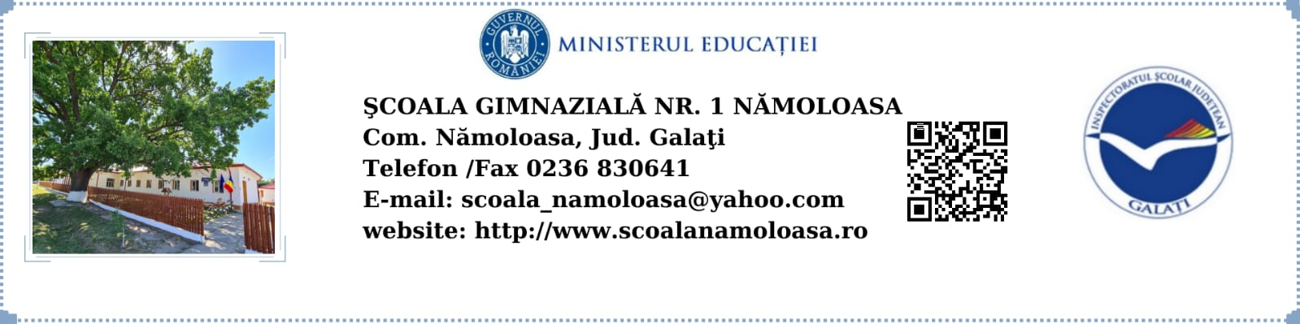

**NR.1300/11.09.2023**

**PROGRAM FUNCŢIONARE: 8.00 – 12.00**

**ORAR CLASA PREGĂTITOARE**

**ANUL ŞCOLAR 2023-2024**

|  |  |  |  |  |  |
| --- | --- | --- | --- | --- | --- |
| **Ora** | **Luni** | **Marți** | **Miercuri** | **Joi** | **Vineri** |
| 8-8.45 | ED. FIZICĂ | LB. ENGLEZĂ | C.L.R. | ED. FIZICĂ | C.L.R |
| 9-9.45 | C.L.R. | M.E.M. | M.E.M. | C.L.R. | D.P. |
| 10.05-10.50 | M.E.M. | C.L.R | D.P. | M.E.M. | M.M. |
| 11.00-11.45 | A.V.A.P | M.M. | OPȚ. C.L.R. | A.V.A.P. | RELIGIE |

**Director,**

**Prof. Pechianu Florin Gigi**